Model Scale
# Source: AI Source: Provided by: [Data Path: Persons Table -> ID Column: 1, Name_En Column: Motasem Essam] -> From: [ChatGPT] on [7/17/2026]
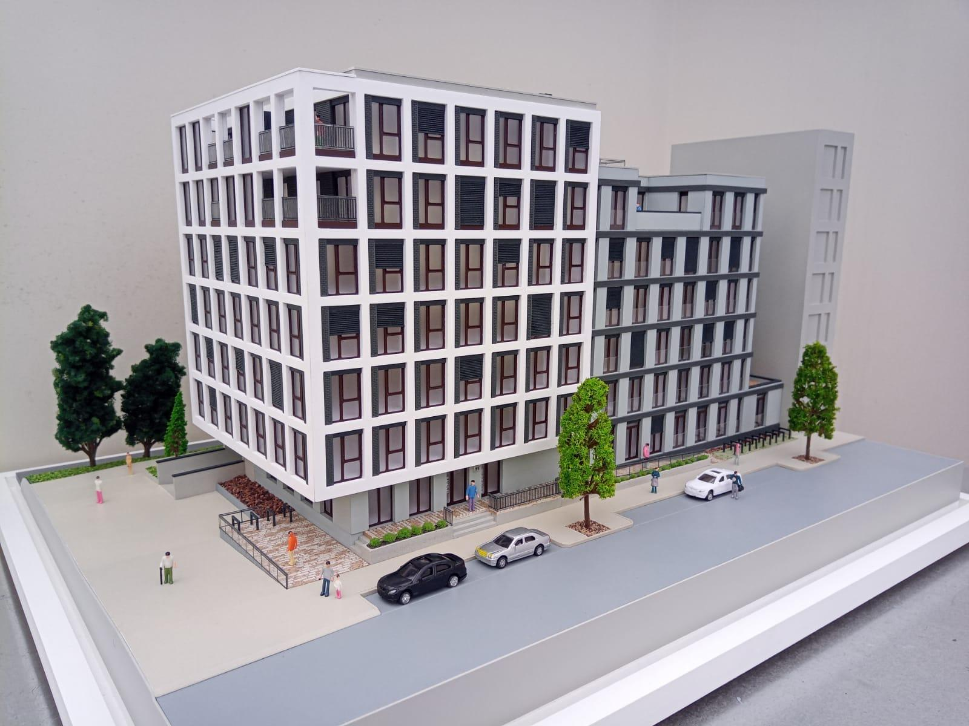
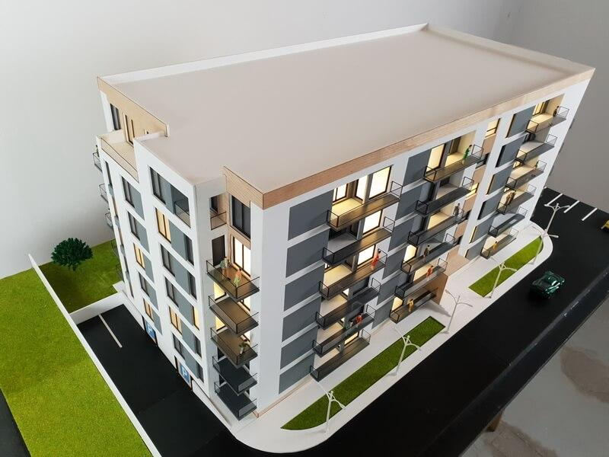
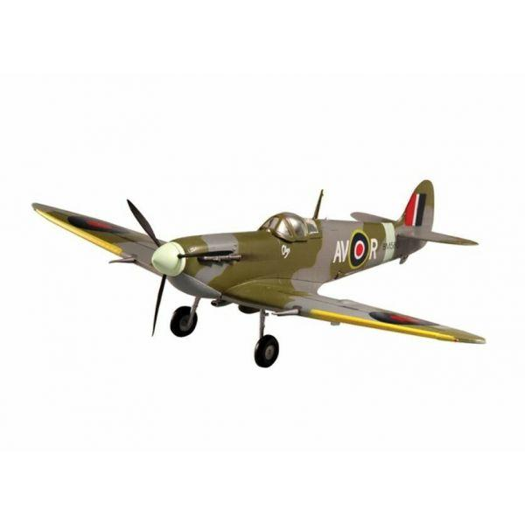
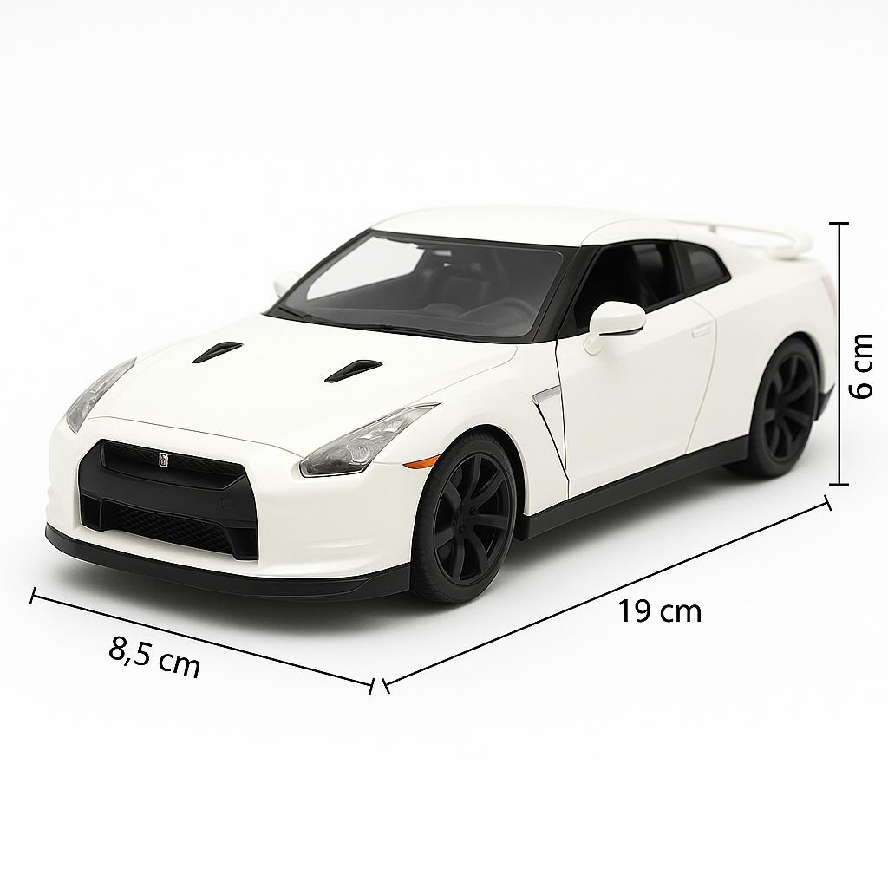
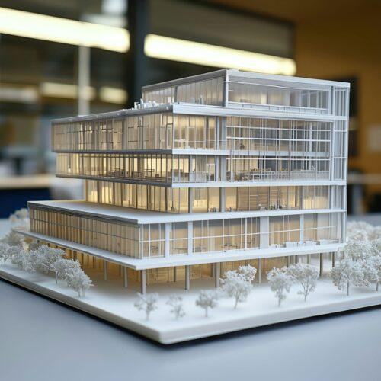
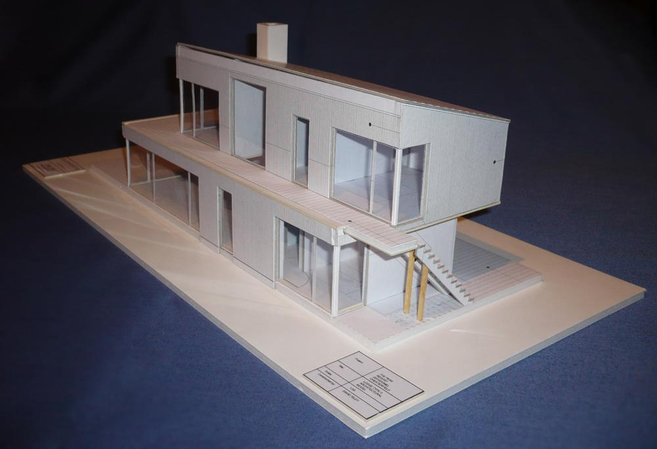
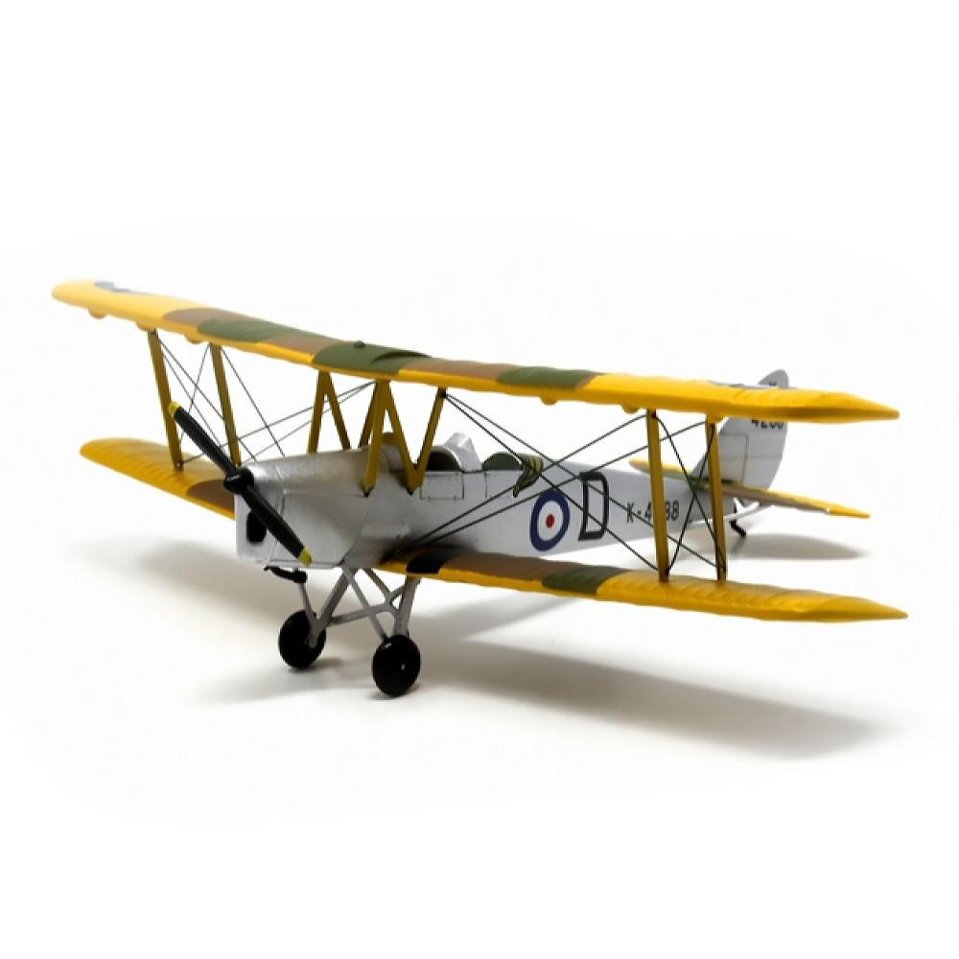
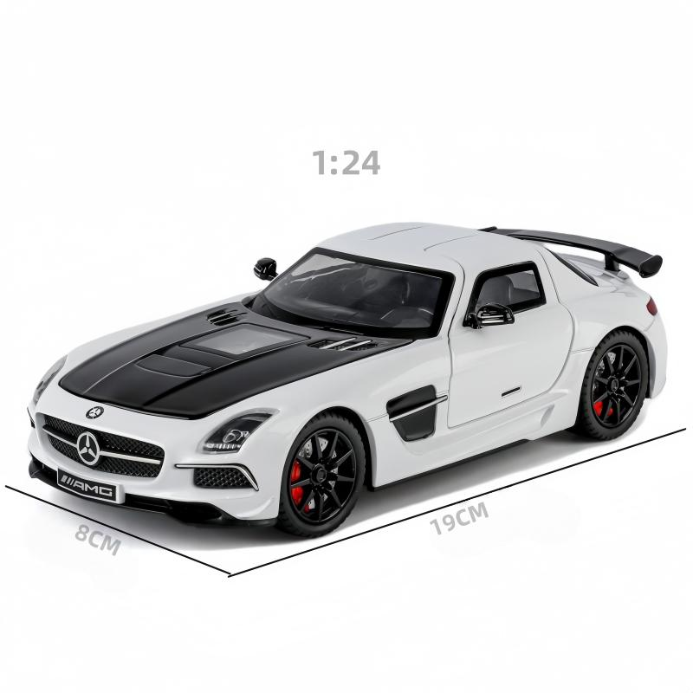
A Model Scale is the fixed ratio between the dimensions of a physical model and the dimensions of the actual object it represents. It is used to create miniature or enlarged replicas while preserving the original object's proportions.
Model scales are widely used in engineering, architecture, transportation, military planning, education, museums, and hobby model building.

Purpose
# Source: AI Source: Provided by: [Data Path: Persons Table -> ID Column: 1, Name_En Column: Motasem Essam] -> From: [ChatGPT] on [7/17/2026]
Model scales are used to:
- Create miniature replicas.
- Visualize large objects.
- Design prototypes.
- Support engineering and architectural planning.
- Produce educational demonstrations.
- Build collectible models.

Principle
# Source: AI Source: Provided by: [Data Path: Persons Table -> ID Column: 1, Name_En Column: Motasem Essam] -> From: [ChatGPT] on [7/17/2026]
A model scale maintains a constant proportional relationship between the model and the real object.
$$\text{Model Scale}=\frac{\text{Model Size}}{\text{Actual Size}}$$
For example,
$$1:100$$
means:
- 1 unit on the model represents 100 units on the real object.

Types of Model Scales

1. Reduction Scale
# Source: AI Source: Provided by: [Data Path: Persons Table -> ID Column: 1, Name_En Column: Motasem Essam] -> From: [ChatGPT] on [7/17/2026]
The model is smaller than the real object.
Examples:
- Buildings
- Aircraft
- Ships
- Vehicles
Typical scales:
- 1:10
- 1:20
- 1:25
- 1:50
- 1:72
- 1:100
- 1:200
- 1:500

2. Full Scale (1:1)
# Source: AI Source: Provided by: [Data Path: Persons Table -> ID Column: 1, Name_En Column: Motasem Essam] -> From: [ChatGPT] on [7/17/2026]
The model is exactly the same size as the actual object.
Applications:
- Industrial prototypes
- Machine parts
- Product testing

3. Enlargement Scale
# Source: AI Source: Provided by: [Data Path: Persons Table -> ID Column: 1, Name_En Column: Motasem Essam] -> From: [ChatGPT] on [7/17/2026]
The model is larger than the original object.
Examples:
- Small mechanical parts
- Biological specimens
- Educational models
Typical scales:
- 2:1
- 5:1
- 10:1

Common Model Scales
# Source: AI Source: Provided by: [Data Path: Persons Table -> ID Column: 1, Name_En Column: Motasem Essam] -> From: [ChatGPT] on [7/17/2026]
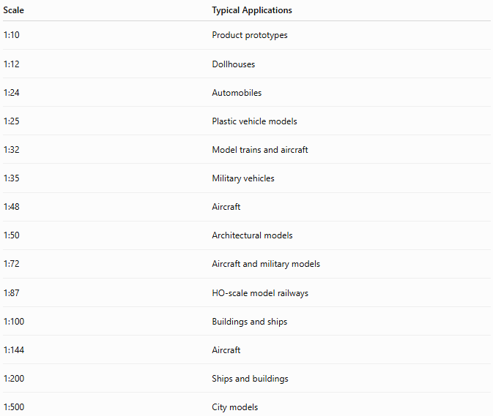
Scale | Typical Applications
1:10 | Product prototypes
1:12 | Dollhouses
1:24 | Automobiles
1:25 | Plastic vehicle models
1:32 | Model trains and aircraft
1:35 | Military vehicles
1:48 | Aircraft
1:50 | Architectural models
1:72 | Aircraft and military models
1:87 | HO-scale model railways
1:100 | Buildings and ships
1:144 | Aircraft
1:200 | Ships and buildings
1:500 | City models

Formula
# Source: AI Source: Provided by: [Data Path: Persons Table -> ID Column: 1, Name_En Column: Motasem Essam] -> From: [ChatGPT] on [7/17/2026]
Actual Dimension
$$\text{Actual Size}=\text{Model Size}×\text{Scale Factor}$$

Model Dimension
$$\text{Model Size}=\frac{\text{Actual Size}}{\text{Scale Factor}}$$

Example
# Source: AI Source: Provided by: [Data Path: Persons Table -> ID Column: 1, Name_En Column: Motasem Essam] -> From: [ChatGPT] on [7/17/2026]
Scale:
$$1:50$$
Actual building height:
$$25\text{ m}$$
Convert to centimeters:
$$25\text{ m}=2500\text{ cm}$$
Model height:
$$\frac{2500}{50}=50\text{ cm}$$
Therefore,
A 25-meter building becomes a 50-centimeter model.

Applications
# Source: AI Source: Provided by: [Data Path: Persons Table -> ID Column: 1, Name_En Column: Motasem Essam] -> From: [ChatGPT] on [7/17/2026]
Model scales are used in:
- Architecture
- Civil engineering
- Mechanical engineering
- Industrial design
- Transportation
- Museums
- Military planning
- Education
- Hobby model building

Advantages
# Source: AI Source: Provided by: [Data Path: Persons Table -> ID Column: 1, Name_En Column: Motasem Essam] -> From: [ChatGPT] on [7/17/2026]
Model scales:
- Preserve proportions.
- Simplify visualization.
- Reduce material costs.
- Support design evaluation.
- Improve communication during planning.

Limitations
# Source: AI Source: Provided by: [Data Path: Persons Table -> ID Column: 1, Name_En Column: Motasem Essam] -> From: [ChatGPT] on [7/17/2026]
Model scales:
- Small scales may omit fine details.
- Large scales require more materials.
- Precision depends on accurate scaling.

Sources of Error
# Source: AI Source: Provided by: [Data Path: Persons Table -> ID Column: 1, Name_En Column: Motasem Essam] -> From: [ChatGPT] on [7/17/2026]
Instrument Errors
- Inaccurate rulers or measuring tools.
- Manufacturing tolerances.

User Errors
- Using the wrong scale ratio.
- Incorrect unit conversion.
- Measurement mistakes during construction.

Environmental Errors
- Material expansion or contraction.
- Warping due to humidity or temperature.

Comparison with Other Scales
# Source: AI Source: Provided by: [Data Path: Persons Table -> ID Column: 1, Name_En Column: Motasem Essam] -> From: [ChatGPT] on [7/17/2026]
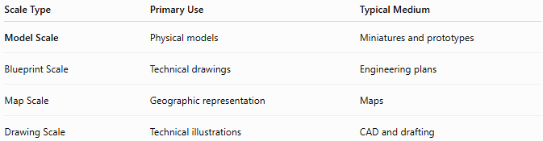
Scale Type | Primary Use | Typical Medium
Model Scale | Physical models | Miniatures and prototypes
Blueprint Scale | Technical drawings | Engineering plans
Map Scale | Geographic representation | Maps
Drawing Scale | Technical illustrations | CAD and drafting

Best Practices
# Source: AI Source: Provided by: [Data Path: Persons Table -> ID Column: 1, Name_En Column: Motasem Essam] -> From: [ChatGPT] on [7/17/2026]
- Select a scale appropriate for the model size and required detail.
- Use consistent measurement units.
- Clearly label the model scale.
- Verify all calculations before construction.
- Use precision measuring tools for accurate fabrication.

Key Points
# Source: AI Source: Provided by: [Data Path: Persons Table -> ID Column: 1, Name_En Column: Motasem Essam] -> From: [ChatGPT] on [7/17/2026]
- A Model Scale is the ratio between a model and the real object.
- Common categories include:
  - Reduction Scale
  - Full Scale (1:1)
  - Enlargement Scale
- Common model scales include:
  - 1:24
  - 1:35
  - 1:48
  - 1:50
  - 1:72
  - 1:87
  - 1:100
- Model scales preserve the object's proportions while changing its size.

Conclusion
# Source: AI Source: Provided by: [Data Path: Persons Table -> ID Column: 1, Name_En Column: Motasem Essam] -> From: [ChatGPT] on [7/17/2026]
A Model Scale provides a proportional relationship between a physical model and the real object it represents. By maintaining consistent dimensions through a fixed scale ratio, model scales enable the creation of accurate miniatures or enlarged replicas for architecture, engineering, transportation, education, museums, industrial design, and hobby model building, making them essential tools for visualization, planning, and communication.

